Assignment 4
Chapter 4

Question 01
Design a 16 X 132 register file.
Note: You must label all the input and output pins

Question 02
Why does the ALU control unit take the following bits as input?
Instruction[30, 14-12]

Question 03
What is the significance of the Zero pin in the ALU?

Question 04
Suppose you have a single instruction;

Add X21, X22, X23

Register read = 20s
Instruction Fetch = 20s
Memory Operation = 40s
Register write = 20s
ALU Operation = 40s

Suppose you have a pipelined setup and a single cycle setup,
Which one will run the instruction faster?

Question 05
Modify the BEQ datapath so that it works for BNE.

Question 06
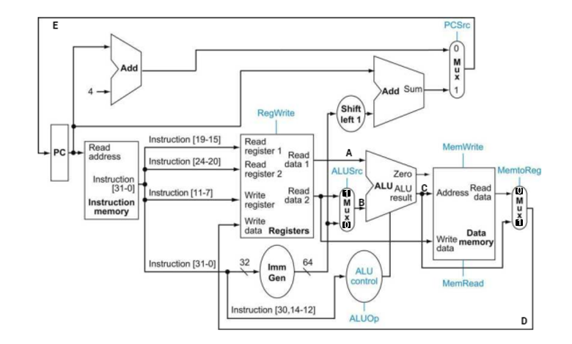
Write the control signals for the following instruction:
Ld X5, 10(X21);

i. ALU Src;
ii. RegWrite;
iii. MemRead;
iv. MemWrite;
v. MemtoReg.
Question 07
Explain control hazard in your own words.

Question 08
Why do we keep instruction and data memory separate?

